Praveen Kumar Yadav

(MTech VLSI Sem 1, EE22M308)

Lab no. : 7

Used version: Matlab 2022

Q.1: Numerical solution of Time dependent Diffusion equation

(a) Describe the formalism to solve time dependent diffusion equation using backward Euler scheme.

Ans:

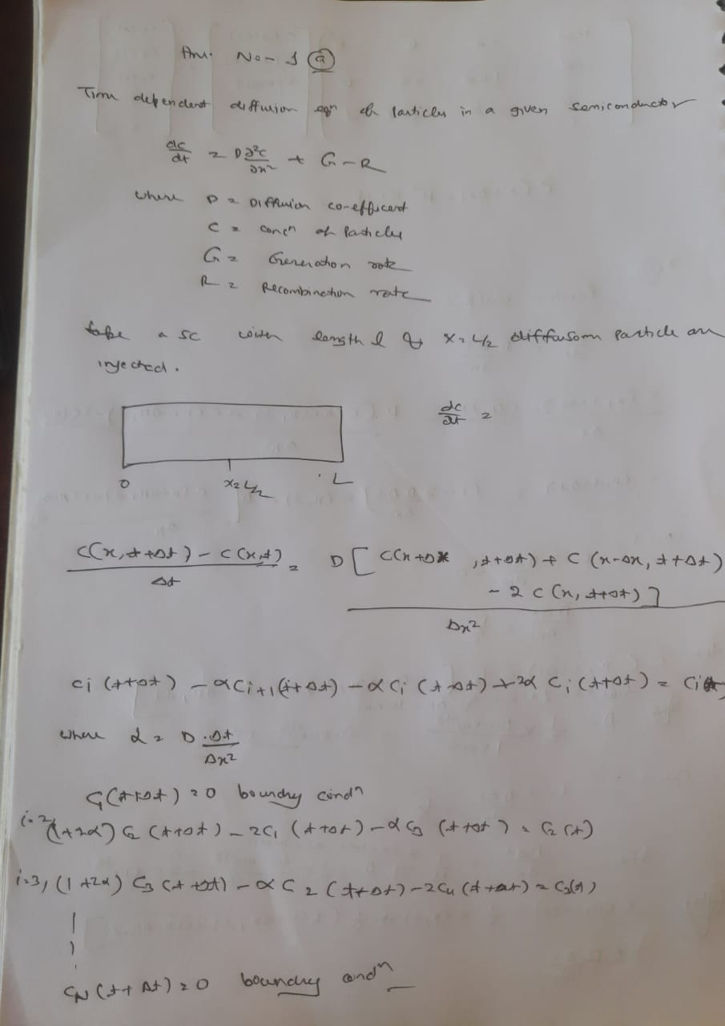

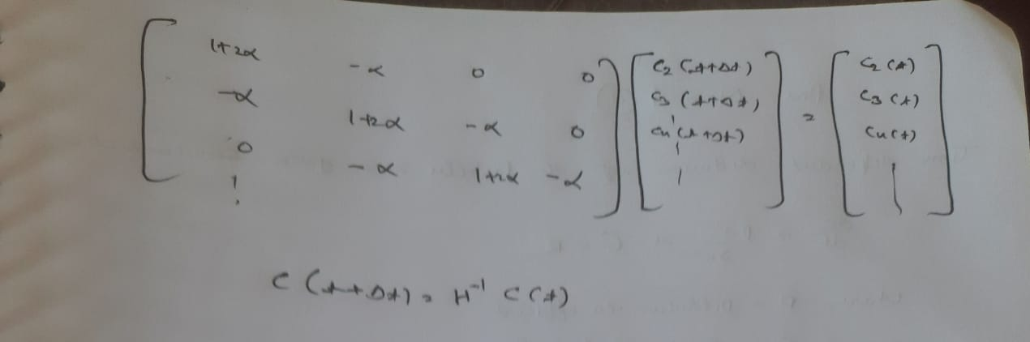

(b) Consider a region of length 10 μm. Assume perfectly absorbing boundary conditions at x=0 and at x=10 μm. At time t=0, assume that particles are injected at x=5 μm is such that the density is 10^6cm-3 (i.e., the injection is a delta function in both space and time). Using the formalism described in (a) explore the evolution of particle density over the specified domain (use D=10-4 cm2/s). Compare with analytical results. Explore the significance of the parameter.

Ans :

Numerical method:

clear all;

clc;

D=10^-4; % take D in cm^2/sec

l=10^-3; % take length in cm

time=100\*10^-6; %take time 100 micro sec

t1=linspace(0,time,100); % take 100 spacing between time

l1=linspace(0,l,100); % take 100 spacing between length

t=10^-6; % small portion of time

h=10^-5; % small portion of distance

a=D\*t/(h^2);

Co=[];

Co = zeros(100,1);

Co(50,1)=10^6;

H=[];

D = [];

for j=1:100

for i =2:100

H(i,i)=1+2\*a;

end

for i=2:99

H(i,i+1)=-a;

end

for i=1:98

H(i+1,i)=-a;

end

H(1,1)=1;

H(100,100)=1;

Cn=inv(H)\*Co;

D=[D,Co];

Co=Cn;

end

plot(l1,D(:,10),l1,D(:,30),l1,D(:,50),l1,D(:,70));

grid on;

xlabel('distance from x=0 position');

ylabel('potential profile');

title('numerical: potential vs distance');

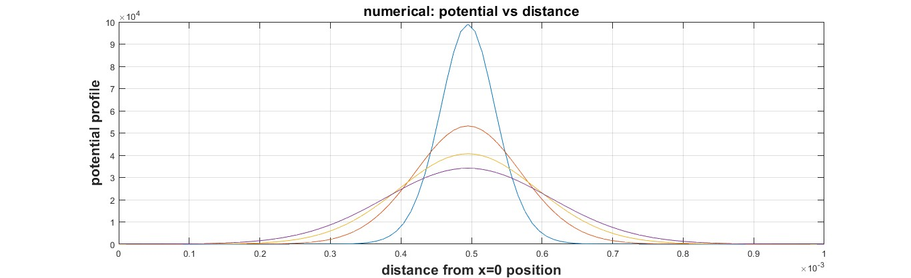

Analytical method:

clear all;

clc;

D=10^-4; % take D in cm^2/sec

l=10^-3; % take length in cm

time1=10\*10^-6; %take time 100 micro sec

time2=30\*10^-6;

time3=50\*10^-6;

time4=70\*10^-6;

% m=linspace(0,time,100); % take 100 spacing between time

k=linspace(0,l,100) ; % take 100 spacing between length

t=10^-6; % small portion of time

h=10^-5; % small portion of distance

Q=1.1\*10^1;

p=[];

a1=2\*((pi\*D\*time1)^0.5);

a2=2\*((pi\*D\*time2)^0.5);

a3=2\*((pi\*D\*time3)^0.5);

a4=2\*((pi\*D\*time4)^0.5);

C1=((Q/a1)\*exp(-((k-(0.5\*l)).^2)/(4\*D\*time1)));

C2=((Q/a2)\*exp(-((k-(0.5\*l)).^2)/(4\*D\*time2)));

C3=((Q/a3)\*exp(-((k-(0.5\*l)).^2)/(4\*D\*time3)));

C4=((Q/a4)\*exp(-((k-(0.5\*l)).^2)/(4\*D\*time4)));

plot(k,C1,k,C2,k,C3,k,C4);

% for i=1:100

%

% p=[p,C];

% plot (p);

% hold on

% end

grid on

xlabel('distance from x=0 position');

ylabel('potential profile');

title('Analytical: potential vs distance');

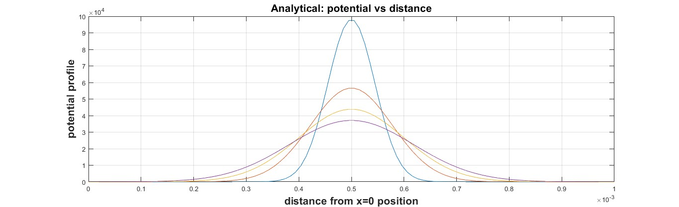

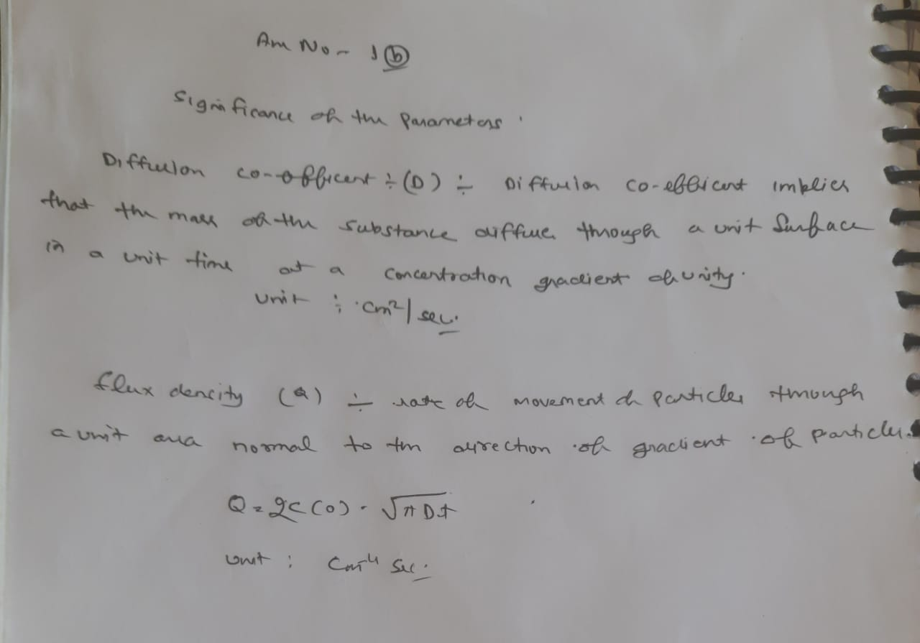

Q.2: Random Walk simulations:

(a) Discretize the time dependent diffusion equation and arrive at a scheme for solving the time dependent diffusion equation through random walk simulations. For D=10-4 cm2/s and Δx=10 nm, what should be the Δt, the time step in such simulations?

Ans:

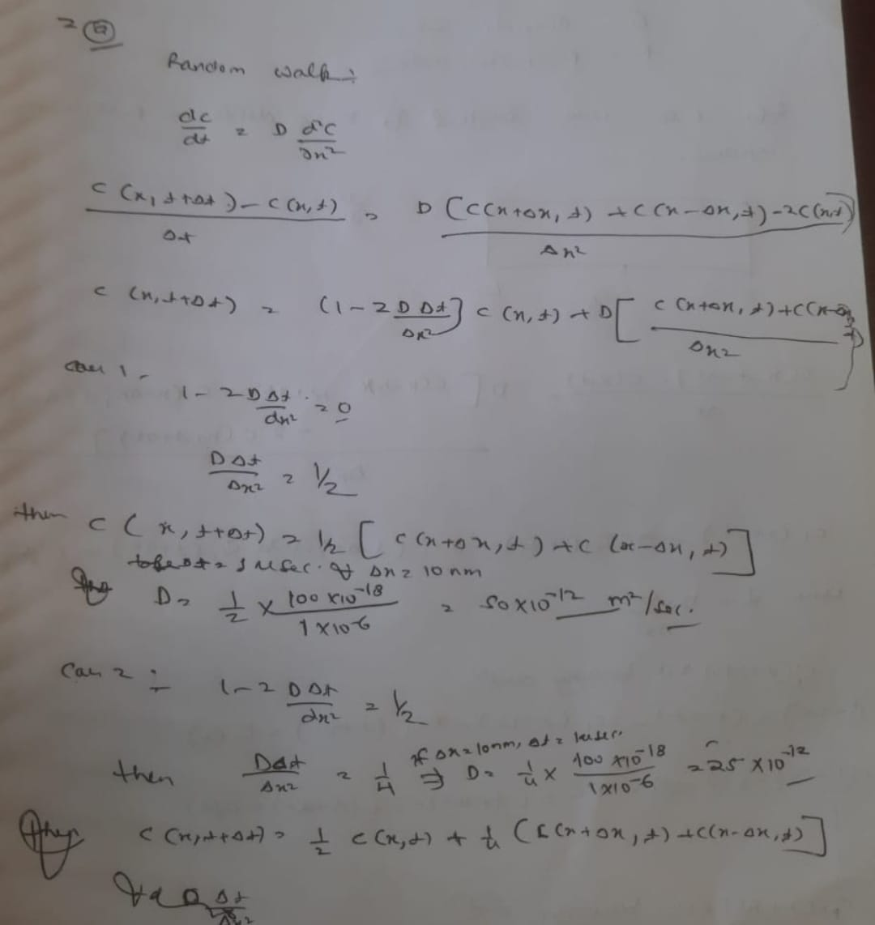

(b) Assume that N=100 particles are released at x=5 μm at t=0. Explore the evolution of particle density profile as a function of time using random walk simulations. Compare with analytical results. Explore the density function for N=1000, and N=10000 particles.

Ans

Code:

For N=100

Numerical:

clc;

clear all;

l=100\*10^-6; % length is 100 micro meters

m=linspace(0,10^-5,1000);

a=1;

c=zeros(1000,1);

c(500,1)=100;

d=[];

hyp=eye(1000);

for i=1:100

% creating jacobian matrix

h=zeros(1000);

for i=2:999

h(i,i-1)=0.5;

h(i,i+1)=0.5;

end

% creating the for loop for iterations 100times

cf=hyp\*(h\*c);

d=[d,c];

c=cf;

%plot(m,d(:,10),m,d(:,30),m,d(:,50),m,d(:,70));

grid on

xlabel('Numerical method : Distance in meters')

ylabel('number of particles')

title('density profile for random walk for N=100')

hold on

end

plot(m,d(:,1),m,d(:,30),m,d(:,50),m,d(:,70));

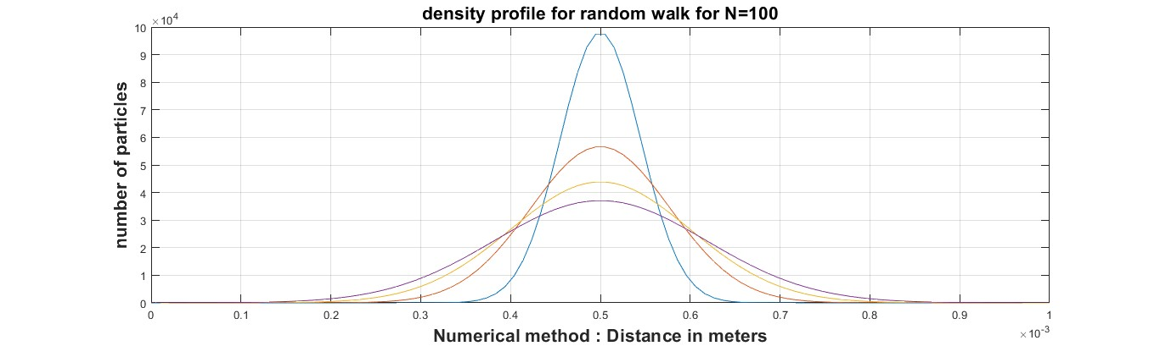

ANALYTICAL:

clear all;

clc;

D=10^-4; % take D in cm^2/sec

l=10^-3; % take length in cm

time1=10\*10^-6; %take time 100 micro sec

time2=30\*10^-6;

time3=50\*10^-6;

time4=70\*10^-6;

% m=linspace(0,time,100); % take 100 spacing between time

k=linspace(0,l,100) ; % take 100 spacing between length

t=10^-6; % small portion of time

h=10^-5; % small portion of distance

Q=0.011;

p=[];

a1=2\*((pi\*D\*time1)^0.5);

a2=2\*((pi\*D\*time2)^0.5);

a3=2\*((pi\*D\*time3)^0.5);

a4=2\*((pi\*D\*time4)^0.5);

C1=((Q/a1)\*exp(-((k-(0.5\*l)).^2)/(4\*D\*time1)));

C2=((Q/a2)\*exp(-((k-(0.5\*l)).^2)/(4\*D\*time2)));

C3=((Q/a3)\*exp(-((k-(0.5\*l)).^2)/(4\*D\*time3)));

C4=((Q/a4)\*exp(-((k-(0.5\*l)).^2)/(4\*D\*time4)));

plot(k,C1,k,C2,k,C3,k,C4);

% for i=1:100

%

% p=[p,C];

% plot (p);

% hold on

% end

grid on

xlabel('distance from x=0 position');

ylabel('potential profile');

title('Analytical method for random walk of 100 particles: potential vs distance');

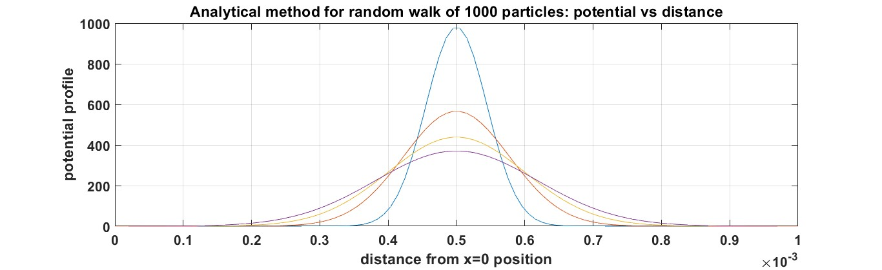

FOR N=1000

NUMERICAL:

clc;

clear all;

l=100\*10^-6; % length is 100 micro meters

m=linspace(0,10^-5,1000);

a=1;

c=zeros(1000,1);

c(500,1)=1000;

d=[];

hyp=eye(1000);

for i=1:100

% creating jacobian matrix

h=zeros(1000);

for i=2:999

h(i,i-1)=0.5;

h(i,i+1)=0.5;

end

% creating the for loop for iterations 100times

cf=hyp\*(h\*c);

d=[d,c];

c=cf;

%plot(m,d(:,10),m,d(:,30),m,d(:,50),m,d(:,70));

grid on

xlabel('Numerical method : Distance in meters')

ylabel('number of particles')

title('density profile for random walk for N=1000')

hold on

end

plot(m,d(:,1),m,d(:,30),m,d(:,50),m,d(:,70));

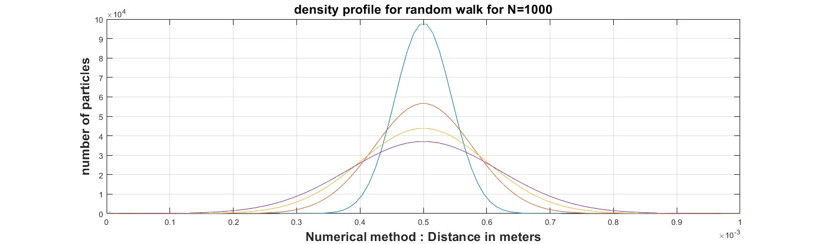

ANALYTICAL:

clear all;

clc;

D=10^-4; % take D in cm^2/sec

l=10^-3; % take length in cm

time1=10\*10^-6; %take time 100 micro sec

time2=30\*10^-6;

time3=50\*10^-6;

time4=70\*10^-6;

% m=linspace(0,time,100); % take 100 spacing between time

k=linspace(0,l,100) ; % take 100 spacing between length

t=10^-6; % small portion of time

h=10^-5; % small portion of distance

Q=0.11;

p=[];

a1=2\*((pi\*D\*time1)^0.5);

a2=2\*((pi\*D\*time2)^0.5);

a3=2\*((pi\*D\*time3)^0.5);

a4=2\*((pi\*D\*time4)^0.5);

C1=((Q/a1)\*exp(-((k-(0.5\*l)).^2)/(4\*D\*time1)));

C2=((Q/a2)\*exp(-((k-(0.5\*l)).^2)/(4\*D\*time2)));

C3=((Q/a3)\*exp(-((k-(0.5\*l)).^2)/(4\*D\*time3)));

C4=((Q/a4)\*exp(-((k-(0.5\*l)).^2)/(4\*D\*time4)));

plot(k,C1,k,C2,k,C3,k,C4);

% for i=1:100

%

% p=[p,C];

% plot (p);

% hold on

% end

grid on

xlabel('distance from x=0 position');

ylabel('potential profile');

title('Analytical method for random walk of 1000 particles: potential vs distance');

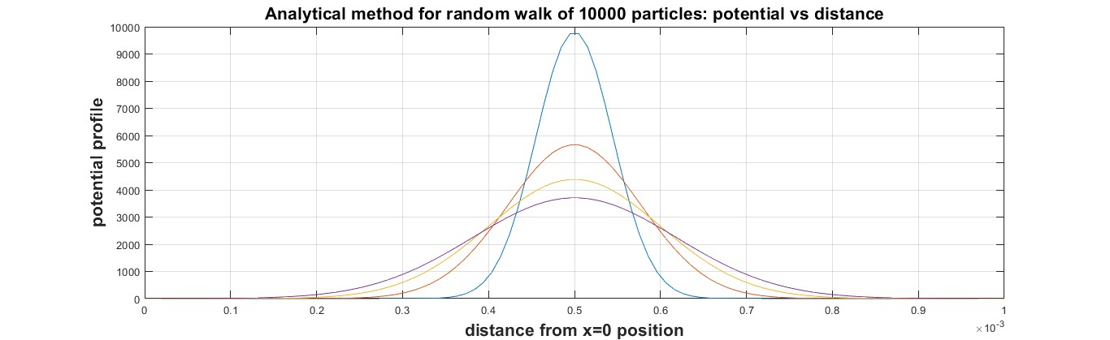

FOR N=10000

NUMERICAL:

clc;

clear all;

l=100\*10^-6; % length is 100 micro meters

m=linspace(0,10^-5,1000);

a=1;

c=zeros(1000,1);

c(500,1)=10000;

d=[];

hyp=eye(1000);

for i=1:100

% creating jacobian matrix

h=zeros(1000);

for i=2:999

h(i,i-1)=0.5;

h(i,i+1)=0.5;

end

% creating the for loop for iterations 100times

cf=hyp\*(h\*c);

d=[d,c];

c=cf;

%plot(m,d(:,10),m,d(:,30),m,d(:,50),m,d(:,70));

grid on

xlabel('Numerical method : Distance in meters')

ylabel('number of particles')

title('density profile for random walk for N=10000')

hold on

end

plot(m,d(:,1),m,d(:,30),m,d(:,50),m,d(:,70));

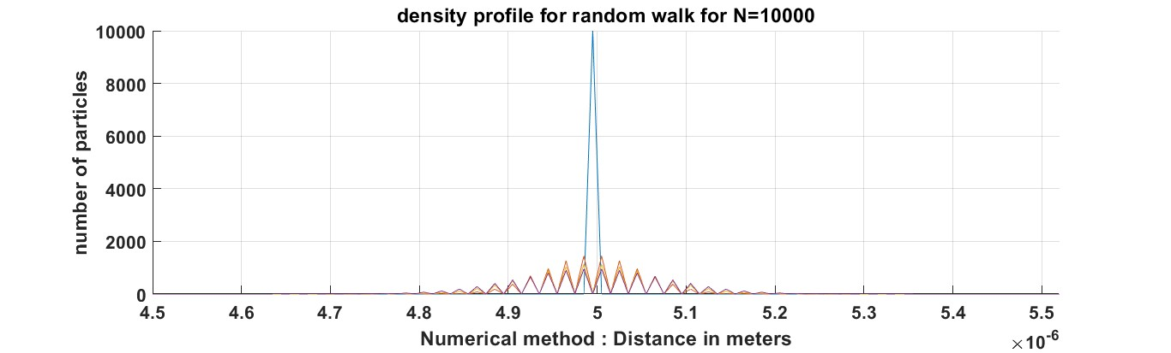

ANALYTICAL:

clear all;

clc;

D=10^-4; % take D in cm^2/sec

l=10^-3; % take length in cm

time1=10\*10^-6; %take time 100 micro sec

time2=30\*10^-6;

time3=50\*10^-6;

time4=70\*10^-6;

% m=linspace(0,time,100); % take 100 spacing between time

k=linspace(0,l,100) ; % take 100 spacing between length

t=10^-6; % small portion of time

h=10^-5; % small portion of distance

Q=1.1;

p=[];

a1=2\*((pi\*D\*time1)^0.5);

a2=2\*((pi\*D\*time2)^0.5);

a3=2\*((pi\*D\*time3)^0.5);

a4=2\*((pi\*D\*time4)^0.5);

C1=((Q/a1)\*exp(-((k-(0.5\*l)).^2)/(4\*D\*time1)));

C2=((Q/a2)\*exp(-((k-(0.5\*l)).^2)/(4\*D\*time2)));

C3=((Q/a3)\*exp(-((k-(0.5\*l)).^2)/(4\*D\*time3)));

C4=((Q/a4)\*exp(-((k-(0.5\*l)).^2)/(4\*D\*time4)));

plot(k,C1,k,C2,k,C3,k,C4);

% for i=1:100

%

% p=[p,C];

% plot (p);

% hold on

% end

grid on

xlabel('distance from x=0 position');

ylabel('potential profile');

title('Analytical method for random walk of 10000 particles: potential vs distance');

